GlucoGraph: Hallucination-Controlled Diabetes Knowledge Graph Construction via LLM Multi-Agent Debate
Quang-Huy LE^{1[0009-0009-0722-9549]}, Van-Ho NGUYEN¹[0000-1111-2222-3333], Vi-Thuan LUU¹[1111-2222-3333-4444], An-Thuan LUU¹ [2222-3333-4444-5555], Manh Huy-DANG¹
¹ School of Digital Technology and Artificial Intelligence, Nam Can Tho University, 168 Nguyen Van Cu Street, An Binh Ward, Can Tho City, Vietnam.
huy223571@student.nctu.edu.vn
Abstract. Knowledge hallucination in Large Language Models (LLMs) is a critical barrier to their clinical deployment, where accuracy is paramount. This paper proposes an end-to-end automated system for constructing a UMLS-standardized Knowledge Graph (KG) for diabetes mellitus, built upon an extended EDC (Extract–Define–Canonicalize) framework enhanced with a Peer-to-Peer Multi-Agent Debate Gate (P2P Debate Gate). Medical text is sourced from Merck Manuals Professional Version and processed through a four-phase pipeline — Extract, Define, Canonicalize, and Property Packing — before storage in Neo4j. A hybrid GraphRAG-powered Clinical Decision Support System (CDSS) is implemented to provide transparent, evidence-grounded diagnosis and treatment recommendations. Experiments on three benchmark datasets confirm the effectiveness of the proposed approach: Full-Triple F1 = 52.24% on BioRED Diabetes (+2.24% over the no-debate baseline); hallucination Trap Rejection Rate = 98.00% (Accuracy = 94.00%) on a 200-sample HaluEval set; and Fact-Extraction F1 = 78.69% on DBpedia-WebNLG, significantly outperforming Vicuna-13B (23.00%) and Alpaca-LoRA-13B (20.00%).
Keywords: Knowledge Graph · Large Language Model · Diabetes Mellitus · EDC Framework · Neo4j · UMLS · GraphRAG · Multi-Agent Debate
- Introduction
Diabetes mellitus is among the most prevalent chronic diseases worldwide, affecting over 537 million adults as of 2021, with projections reaching 783 million by 2045 (International Diabetes Federation [IDF], 2021). The volume of clinical literature on diabetes treatment is growing faster than any single clinician can assimilate, under-scoring the urgent need for automated knowledge extraction and intelligent deci-sion-support tools
Large Language Models (LLMs) have demonstrated remarkable natural language understanding, raising hopes for their clinical application. However, knowledge hal-lucination — the generation of factually incorrect or unsupported statements — pos-es a critical safety risk in medical settings (Ji et al., 2023). A hallucinated drug inter-action or misclassified clinical relationship could directly endanger patients.
Knowledge Graphs (KGs) offer a complementary paradigm: explicit, structured repre-sentations of entities and relationships that support multi-hop reasoning and trans-parent provenance. Graph Retrieval-Augmented Generation (GraphRAG; Edge et al., 2024) combines the fluency of LLMs with the factual grounding of KGs, but the con-struction quality of the underlying KG remains the bottleneck.
This paper addresses that bottleneck. We present three principal contributions:
– An extended four-phase EDC pipeline (Extract–Define–Canonicalize–Property Packing) that maps free-form clinical triples to UMLS CUI-anchored ontology nodes, eliminating synonym ambiguity.
– A P2P Multi-Agent Debate Gate comprising three specialized AI agents (Clinical Specialist, Ontology Inspector, Medical Skeptic) with a consensus scoring mechanism (FCS ≥ 80) and a clinical Veto Rule, achieving a Trap Rejection Rate of 98.00%.
– A hybrid GraphRAG CDSS (FastAPI + ReactJS + Neo4j) that delivers evidence-grounded diagnostic reasoning with a real-time Clinical Circuit Breaker for contraindicated drug alerts.
The system design, model architecture, and experimental results are detailed in Sections 3, 4, and 5 respectively.
- Related Work
  - Biomedical Knowledge Graphs and UMLS
Biomedical KGs such as UMLS (Bodenreider, 2004), SNOMED CT, and DrugBank encode standardized clinical terminologies and drug-disease relationships. UMLS integrates over 200 source vocabularies under a single Concept Unique Identifier (CUI) system, making it the de facto standard for entity normalization in clinical NLP. Prior KG construction approaches relied on manual curation or rule-based ex-traction, which do not scale to the rate of medical literature growth. Recent work has demonstrated the benefit of coupling KGs with LLMs for clinical tasks: Xu et al. (2025) proposed medIKAL, which integrates KGs as dynamic assistants of LLMs on electronic medical records, yielding measurable gains in diagnostic accuracy; Zheng et al. (2026) showed that automated biomedical KG construction enables context-aware scientific inference at scale. Both works reinforce the necessity of high-quality, hallucination-controlled KG construction that our system targets.
  - LLM-Based Knowledge Extraction
The EDC (Extract–Define–Canonicalize) framework (Zhang & Soh, 2024) pioneered a three-phase LLM-driven pipeline for open KG construction, demonstrating that iterative prompting can guide models to produce ontology-consistent triples aligned to a reference schema (Noy & McGuinness, 2001). However, EDC's original formula-tion lacks biomedical identifier integration and quality gating. Khorashadizadeh et al. (2023) benchmarked Vicuna-13B and Alpaca-LoRA-13B on DBpedia-WebNLG, reporting F1 scores of 23.00% and 20.00% respectively — baselines that our system substantially exceeds.
  - Hallucination Detection and Multi-Agent Debate
Ji et al. (2023) provide a comprehensive survey of hallucination in NLG, classifying failure modes relevant to clinical contexts. The HaluEval benchmark (Li et al., 2023) formalizes adversarial triple sets for evaluating detection robustness. Du et al. (2024) showed that multi-agent debate improves LLM factual accuracy in general-domain reasoning tasks; Chan et al. (2024) extended this paradigm to LLM-based evaluation through ChatEval, demonstrating that diverse agent roles elicit more accurate judg-ments. However, both frameworks use homogeneous agents with no domain-specific stopping conditions. Our P2P Debate Gate departs in three concrete ways: (1) agents are assigned heterogeneous specialist roles (Clinical Specialist, Ontology Inspector, Medical Skeptic) rather than generic debaters, enabling targeted error detection; (2) an asymmetric Veto Rule (any single Sᵢ < 30 overrides the consensus) enforces clini-cal conservatism absent from Du et al.'s majority-vote design; and (3) the gate oper-ates at the structured triple level rather than at free-text generation, enabling integra-tion with an ontology schema and UMLS CUI anchoring.
  - Clinical Decision Support Systems
GraphRAG (Edge et al., 2024) enhances retrieval-augmented generation by travers-ing KG paths, providing multi-hop reasoning capabilities suited to differential diag-nosis. Existing CDSS systems either rely on static knowledge bases (American Diabe-tes Association, 2024) or lack integrated hallucination controls. Recent work on LLM evaluation in specialized chatbot domains (Ngo et al., 2026; Ngo-Ho et al., 2025) has highlighted that standard metrics are insufficient for domain-specific de-ployment. For diabetes specifically, Evangelista et al. (2026) demonstrated a Gra-phRAG-enabled local LLM proof-of-concept for gestational diabetes, while Wang et al. (2025) developed an intelligent diabetes Q&A system integrating KGs with LLMs. Wu et al. (2025) further showed that evidence-based medical LLMs built on GraphRAG substantially outperform ungrounded baselines in clinical question an-swering. Our work bridges these gaps by unifying dynamic KG construction, multi-agent quality control, and hybrid GraphRAG inference into a single reproducible pipeline.
- Proposed System
  - System Architecture Overview
As illustrated in Fig. 1, the proposed system follows a five-stage end-to-end pipeline: (1) Text Preprocessing, (2) EDC Pipeline, (3) Agent Debate Gate, (4) Post-processing and Neo4j Loading, and (5) CDSS Demo. Each stage is modular, enabling independ-ent evaluation and replacement of components.
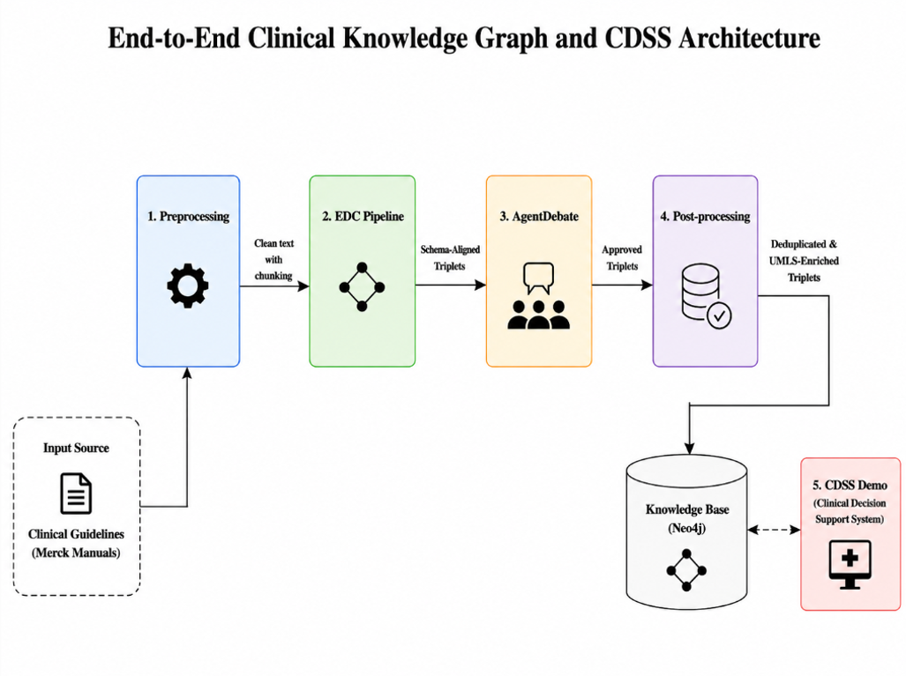
Fig. 1. End-to-end clinical knowledge graph construction and CDSS architecture.
  - Data Source and Preprocessing
Clinical text is sourced from Merck Manuals Professional Version, diabetes mellitus section — a peer-reviewed clinical reference updated continuously by medical ex-perts. Raw HTML content is scraped, stripped of formatting artifacts, and segmented into clinically coherent chunks of approximately 256 tokens using a sliding-window strategy with 32-token overlap to preserve cross-sentence context.
  - Extended EDC Pipeline
The EDC framework is extended from three to four phases, gated by a peer-to-peer multi-agent debate stage, as illustrated end-to-end in Fig.
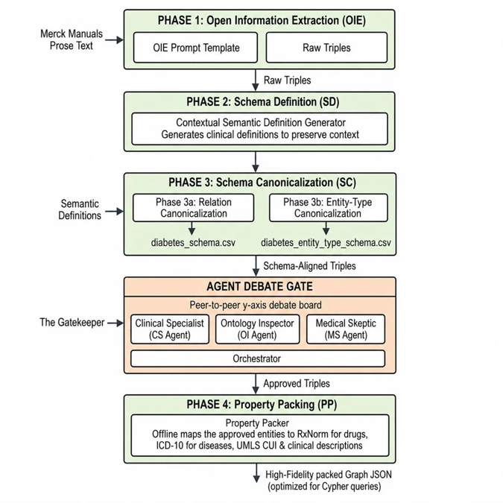
Fig. 2. Extended EDC pipeline: Open Information Extraction (Phase 1) and Schema Definition (Phase 2) precede two-branch Schema Canonicalization (Phase 3a/3b); the Agent Debate Gate then approves Schema-Aligned Triples for Property Packing (Phase 4), yielding a high-fidelity, Cypher-ready graph JSON.
Phase 1 — Extract. A few-shot prompt instructs Llama-3.3-70B-Versatile to per-form Open Information Extraction (Open IE), producing raw triples (Subject, Rela-tion, Object) without schema constraints, maximizing recall.
Phase 2 — Define. The LLM generates a contextual semantic definition for each entity and relation based on the source sentence. These definitions serve as disam-biguation anchors and evidence for downstream canonicalization.
Phase 3 — Canonicalize. Qwen-Embedding encodes entity and relation texts into dense vectors. Cosine similarity is computed against reference schema files along two parallel branches: Phase 3a (Relation Canonicalization) maps relations against diabe-tes_schema.csv, while Phase 3b (Entity-Type Canonicalization) maps entity types against diabetes_entity_type_schema.csv. For each entity and relation, the Top-K candidates (K = 5) exceeding similarity threshold τ = 0.75 are retained as a coarse-filtered candidate set, rather than being directly accepted as the final mapping. A Verifier LLM (Llama-3.1-8B) then selects the best-matching canonical type from this candidate set via multiple-choice verification — including automatic detection and correction of subject–object direction — or returns “None” if no candidate semantically valid, in which case the triple is discarded. If no candidate exceeds τ, the triple is rejected at this stage without invoking the Verifier LLM. The two branches converge into a single stream of Schema-Aligned Triples.
Agent Debate Gate — The Gatekeeper. Before reaching Property Packing, every Schema-Aligned Triple is routed through the peer-to-peer debate board — the Clini-cal Specialist, Ontology Inspector, and Medical Skeptic agents, coordinated by an Orchestrator — which outputs Approved Triples. The full consensus-scoring mechan-ics are detailed in Section 3.4.
Phase 4 — Property Packing. An offline Property Packer maps each approved en-tity to standardized medical identifiers — RxNorm codes for drugs, ICD-10 codes for diseases, and UMLS CUI with clinical descriptions for all entities — while entity resolution merges synonymous mentions and abbreviations onto a single CUI-anchored node. The output is a High-Fidelity packed Graph JSON, optimized for downstream Cypher queries.
  - P2P Multi-Agent Debate Gate
Before any triple is written to Neo4j, it must pass a three-agent peer debate, as illus-trated in Fig. 3. Each agent i independently assigns a score Sᵢ ∈ [0, 100] reflecting its domain-specific confidence in the triple's validity. The Final Consensus Score is de-fined as FCS = (S₁ + S₂ + S₃) / 3, where S₁, S₂, S₃ are the scores of the Clinical Special-ist, Ontology Inspector, and Medical Skeptic respectively. A triple is admitted only if FCS ≥ 80 and no individual Sᵢ triggers the Veto Rule (Sᵢ < 30). The three agents and their mandates are as follows.
– Clinical Specialist (Llama-3.3-70B): Evaluates clinical accuracy of the relation against current ADA/ICD-10 guidelines, assigning a score S₁ ∈ [0, 100].
– Ontology Inspector (Llama-3.1-8B): Checks Domain/Range constraint compli-ance with the loaded ontology schema, assigning S₂ ∈ [0, 100].
– Medical Skeptic (Gemma-3-27B): Independently audits for subject–object in-version, direction errors, and hallucination patterns, assigning S₃ ∈ [0, 100]
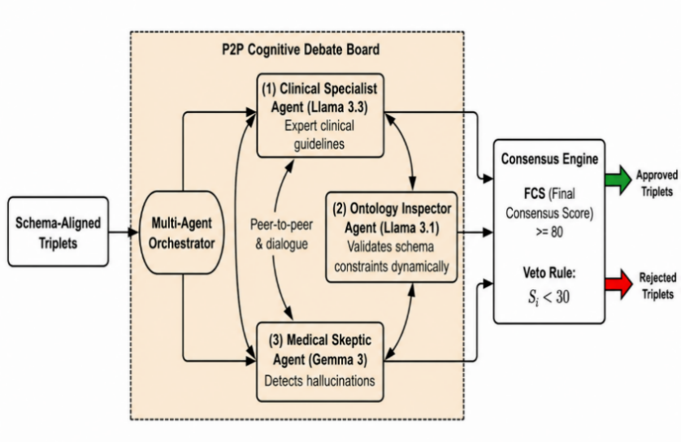
Fig. 3. P2P Cognitive Debate Board architecture: three specialist agents engage in peer-to-peer dialogue, and the Consensus Engine applies the FCS ≥ 80 threshold and Veto Rule to approve or reject schema-aligned triplets.
The approval decision thus requires both high average agreement (FCS ≥ 80) and no individual veto (Sᵢ < 30).
Notably, under the current three-agent configuration, these two conditions are math-ematically reinforcing rather than independent. If any single agent triggers the veto with a score just below the threshold (e.g., Sᵢ = 29), the maximum attainable FCS — even if the remaining two agents both assign a perfect score of 100 — is (100 + 100 + 29) / 3 ≈ 76.33, which can never reach the FCS ≥ 80 threshold. Hence, triggering the Veto Rule and failing the FCS condition are equivalent events in this configuration: any triple that violates the veto also necessarily fails the consensus threshold, and the converse, while not strictly required, holds for all observed rejections in our experi-ments. In practice, the veto functions as a computational shortcut, allowing immedi-ate rejection of a triple as soon as one agent reports Sᵢ < 30, without needing to com-pute the full consensus score. This equivalence is configuration-dependent rather than a general property of the framework: extending the panel to four or more agents would decouple the two conditions, at which point the Veto Rule would constitute a genuinely independent rejection criterion rather than a redundant shortcut. We retain both conditions explicitly in the current design to preserve this extensibility for fu-ture multi-agent configurations.
Rejected triples are logged for post-hoc analysis. This conservative policy imple-ments medical conservatism: it is preferable to exclude uncertain triples than to ad-mit clinically harmful ones.
  - Neo4j Storage and Cypher Import
Approved triples are serialized to JSON and imported into Neo4j via Cypher MERGE statements, ensuring idempotent loading. Node labels correspond to UMLS semantic types (e.g., Pharmacologic Substance, Disease or Syndrome). Relationship types fol-low the canonical schema (TREATED_BY, HAS_FINDING, CO_OCCURS_WITH, CONTRAINDICATED_WITH).
  - Hybrid GraphRAG CDSS
The CDSS web application (FastAPI backend, ReactJS frontend) implements a hybrid retrieval strategy: (1) semantic vector search on entity embeddings to identify candi-date seed nodes; (2) multi-hop Cypher traversal from seeds to retrieve diagnostic and treatment subgraphs; and (3) LLM synthesis of the retrieved subgraph into a struc-tured clinical response with differential diagnoses, treatment recommendations, and confidence scores. A Clinical Circuit Breaker module scans retrieved paths for CONTRAINDICATED_WITH edges and triggers a red-alert banner if any contraindi-cation is detected.
- Experimental Results
  - Experimental Setup
All experiments were conducted on a lab environment connected via OpenRouter API (Llama-3.3-70B, Llama-3.1-8B, Gemma-3-27B) and a local Neo4j Community Edition instance. Three benchmark datasets were used: BioRED Diabetes (Luo et al., 2022; PubMed relation extraction, diabetes subset); a 200-sample adversarial HaluE-val set constructed specifically for this study (100 valid triples, 100 injected trap triples); and DBpedia-WebNLG (1_university topic, 71 documents) for domain-generalization evaluation. Evaluation follows strict/exact match as per SemEval conventions.
  - Triple Extraction Quality — BioRED Diabetes
Table 1 compares the Raw system (no debate gate) against the full Debate system across five F1 metrics.
Table 1. Triple Extraction F1-Score Comparison — BioRED Diabetes Dataset
Metric | Raw (No Gate) | Debate (With Gate) | Δ
Subject F1 | 67.24% | 69.09% | +1.85%
Predicate F1 | 77.59% | 80.00% | +2.41%
Object F1 | 67.73% | 69.61% | +1.88%
Exact Match F1 | 70.66% | 72.70% | +2.04%
Full-Triple F1 | 50.00% | 52.24% | +2.24%

The Debate Gate consistently improves all ablation metrics on the BioRED diabe-tes subset. The largest gain occurs on Predicate F1 (+2.41 pp), indicating that agent debate
most effectively filters incorrect relation labels — the highest-risk component for downstream reasoning. Full-Triple F1 improves by 2.24 pp, from 50.00% to 52.24%. For broader context, Brokman et al. (2025) reported that GPT-4 in an end-to-end ze-ro-shot setting achieves only ~8–10% Full-Triple F1 on the full BioRED corpus (all relation types), and PubMedBERT fine-tuned on the BioCreative VIII challenge achieves 51.93% Entity Pair identification F1 on the full corpus (Islamaj et al., 2024); both figures are reported on a substantially larger and more heterogeneous evaluation scope than the diabetes subset used here, and are therefore not directly comparable. Direct ablation comparison (Raw vs. Debate) on the same diabetes sub-set remains the primary evidence for the Debate Gate's contribution.
  - Hallucination Detection — HaluEval
To establish a rigorous, reproducible, and objective triple-level hallucination benchmark without subjective human annotation bias, we proposed an algorithmic ground-truth validation pipeline derived from the expert-curated BioRED dataset. Ground-truth relations within the diabetes subset of BioRED served as valid (posi-tive) triples. Corrupted (negative) triples were programmatically generated using three distinct strategies: entity substitution, relation inversion, and schema violation. To ensure validity, a corrupted triple was algorithmically labeled as ‘Invalid’ only if it strictly violated the domain/range constraints of the reference ontology, or was cross-referenced to ensure zero occurrence in both the BioRED corpus and the Merck Manuals. This programmatic framework yields a deterministic evaluation set suited for benchmarking multi-agent debate performance.
Table 2 reports the confusion matrix and derived metrics from the 200-sample HaluEval experiment.
Table 2. HaluEval Confusion Matrix and Performance Metrics
Triple Class | Accepted | Blocked | Total | Metric
Valid (Ground truth +) | 90 (TP) | 10 (FN) | 100 | Accuracy = 94.00%
Trap (Hallucination) | 2 (FP) | 98 (TN) | 100 | TRR = 98.00%

The system achieves a Trap Rejection Rate (TRR) of 98.00%, with only two trap triples evading detection out of 100 injected cases — both involving subject–object inversions in complex emergency clinical scenarios. The False Negative Rate of 10.00% (10 valid triples blocked out of 100) reflects intentional medical conserva-tism: triples involving complex genetics or unverifiable nutraceutical claims (e.g., chromium supplementation) are withheld pending stronger evidence, consistent with clinical safety standards.
  - Domain Generalization — DBpedia-WebNLG
Table 3 evaluates knowledge extraction quality on a general-domain benchmark, comparing the proposed EDC framework against published baseline
Table 3. Knowledge Extraction Performance — DBpedia-WebNLG (1_university, 71 docs)
Model / Configuration | Precision | Recall | F1
Alpaca-LoRA-13B | 29.00% | 16.00% | 20.00%
Vicuna-13B | 31.00% | 19.00% | 23.00%
EDC (w/o post-processing) | 70.40% | 51.98% | 57.96%
EDC + Post-processing (ours) | 86.03% | 74.44% | 78.69%
LLaMA-65B (2-shot) | — | — | ~21.9%

Note: LLaMA-65B 2-shot F1 on DBpedia-WebNLG is from Papaluca et al. (2024). An em dash (—) indicates the metric was not reported.
The F1 scores reported in Table 3 follow the exact evaluation convention estab-lished by two authoritative sources for this benchmark: (1) the original paper intro-ducing the DBpedia-WebNLG dataset used in this study, Khorashadizadeh et al. (2023); and (2) the evaluation_script.py inherited directly from the official codebase of the WebNLG Challenge, the largest established competition for Text-to-Triples extraction. Adhering to this standard evaluation procedure ensures methodological consistency and direct comparability between the proposed system and the published baselines.
EDC + Post-processing achieves F1 = 78.69% on DBpedia-WebNLG (1_university, 71 docs) — 3.42× Vicuna-13B and 3.93× Alpaca-LoRA-13B, evaluat-ed under identical conditions (Khorashadizadeh et al., 2023). LLaMA-65B in a 2-shot setting achieves only ~21.9% F1 on the same WebNLG benchmark (Papaluca et al., 2024), confirming that structured pipeline design delivers far greater gains than raw model scale. For broader context, Lai et al. (2025) report that GPT-4 zero-shot achieves 20.85% Relation Type F1 on BioRED (a different dataset); this figure is cited in Section 5 for qualitative perspective and is not directly comparable to the Table 3 results.
- Discussion
  - Principal Findings
Three findings stand out. First, the multi-agent Debate Gate improves extraction quality across all metrics while delivering near-perfect hallucination suppression (TRR = 98.00%). Second, the Property Packing phase — absent from the original EDC specification — proved essential in practice: real biomedical text contains dense synonym variation that cannot be resolved by canonicalization alone. Third, the EDC architecture generalizes well beyond the medical domain, suggesting broad applicability to structured knowledge extraction tasks.
  - Strengths and Limitations
The primary strength is the end-to-end measurability: every subsystem is evaluated on standard benchmarks with reproducible scripts, enabling direct comparison with future
work. The integration of UMLS CUI anchoring provides semantic interoperability absent from general-purpose KG systems.
Limitations include the following: (1) the single data source (Merck Manuals) limits coverage; multi-source integration with PubMed and WHO guidelines is needed for production deployment; (2) the FNR of 10.00% indicates that the current agent con-figuration is overly conservative on nuanced or indirect relations, which may reduce recall in downstream CDSS tasks; and (3) the CDSS has not undergone prospective clinical validation with practicing physicians, which is required before any real-world deployment.
  - Comparison With Prior Work
Unlike unconstrained LLM extractors (Khorashadizadeh et al., 2023) that treat KG construction as a single-pass generation task, our approach enforces structural con-straints at every pipeline stage, yielding a 3.42× F1 improvement on DBpedia-WebNLG. For qualitative context across settings, Lai et al. (2025) report 20.85% Re-lation Type F1 for GPT-4 zero-shot on BioRED, and Papaluca et al. (2024) report ~21.9% F1 for LLaMA-65B in a 2-shot setting on WebNLG — both substantially lower than our 78.69%, underscoring that raw model scale without structured pipe-line design remains insufficient for high-quality knowledge extraction. Furthermore, Brokman et al. (2025) demonstrated that even GPT-4 achieves only ~8–10% Full Triple F1 on the full BioRED corpus in an end-to-end zero-shot setting; our Debate pipeline achieves 52.24% Full-Triple F1 on the BioRED diabetes subset — a stricter task scope — without any task-specific fine-tuning. Against KARMA (Lu et al., 2025), a concurrent NeurIPS 2025 spotlight multi-agent KGC system achieving 83.1% LLM-verified correctness on PubMed biomedical abstracts, our system is dis-tinguished by explicit triple-level hallucination gating and UMLS CUI anchoring. All pipeline scripts and evaluation code are publicly available (Le et al., 2025) to ensure full reproducibility.
  - Future Work
Immediate priorities are as follows: (1) expanding the data pipeline to ingest PubMed abstracts and UpToDate content via automated ETL; (2) reducing FNR through agent fine-tuning on a curated diabetes triple dataset; (3) conducting a prospective clinical evaluation with endocrinologists to validate CDSS recommendations against physi-cian judgment; and (4) exploring lightweight deployment of the Canonicalize and Debate modules using quantized smaller models suitable for on-premises hospital infrastructure.
- Conclusion
This paper presented an end-to-end system for constructing a UMLS-constrained dia-betes Knowledge Graph using LLMs, validated on three benchmark datasets. The proposed extended EDC pipeline with P2P Multi-Agent Debate Gate achieves Full
Triple F1 = 52.24% (+2.24% over the no-debate baseline), hallucination Trap Rejec-tion Rate = 98.00%, and general-domain Fact-Extraction F1 = 78.69%. These results demonstrate that structured pipeline design, ontology-constrained canonicalization, and domain-specialized multi-agent review collectively produce a knowledge graph suitable for safe clinical decision support. The integrated hybrid GraphRAG CDSS provides transparent, evidence-grounded reasoning with an automated Clinical Cir-cuit Breaker, offering a reproducible architecture for future intelligent clinical infor-matics systems.
The authors would like to express their sincere gratitude to M.Sc. Dang Manh Huy (Faculty of Information Technology, Nam Can Tho University) for his dedicated aca-demic supervision and invaluable guidance throughout this research.

References
- International Diabetes Federation. (2021). IDF Diabetes Atlas (10th ed.). IDF. https://www.diabetesatlas.org
- Ji, Z., Lee, N., Frieske, R., Yu, T., Su, D., Xu, Y., Ishii, E., Bang, Y. E., Madotto, A., & Fung, P. (2023). Survey of hallucination in natural language generation. ACM Computing Surveys, 55(12), 1–38. https://doi.org/10.1145/3571730
- Edge, D., Trinh, H., Cheng, N., Bradley, J., Chao, A., Mody, A., Truitt, S., & Larson, J. (2024). From local to global: A graph RAG approach to query-focused sum-marization (arXiv:2404.16130). arXiv. https://arxiv.org/abs/2404.16130
- Bodenreider, O. (2004). The unified medical language system (UMLS): Integrat-ing biomedical terminology. Nucleic Acids Research, 32(D1), D267–D270. https://doi.org/10.1093/nar/gkh061
- Zhang, E., & Soh, H. (2024). Extract, define, canonicalize: An LLM-based frame-work for knowledge graph construction. In Proceedings of EMNLP (pp. 9548–9562). Association for Computational Linguistics.
- Khorashadizadeh, H., Mihindukulasooriya, N., Tiwari, S., Groppe, J., & Groppe, S. (2023). Exploring in-context learning capabilities of foundation models for generating knowledge graphs from text (arXiv:2306.11702). arXiv. https://arxiv.org/abs/2306.11702
- Li, J., Cheng, X., Zhao, W. X., Nie, J.-Y., & Wen, J.-R. (2023). HaluEval: A large-scale hallucination evaluation benchmark for large language models. In Pro-ceedings of EMNLP (pp. 6449–6464). Association for Computational Linguis-tics.
- Du, Y., Li, S., Torralba, A., Tenenbaum, J. B., & Mordatch, I. (2024). Improving factuality and reasoning in language models through multiagent debate. In Proceedings of ICML
- American Diabetes Association. (2024). Standards of care in diabetes—2024. Dia-betes Care, 47(Suppl. 1), S1–S321. https://doi.org/10.2337/dc24-SINT
- Brokman, J., et al. (2025). A benchmark for end-to-end zero-shot biomedical re-lation extraction with LLMs: Experiments with OpenAI models (arXiv:2504.04083). arXiv. https://arxiv.org/abs/2504.04083
- Lai, Y., et al. (2025). Enhancing biomedical relation extraction with directionali-ty. Bioinformatics. Advance online publication.
- Papaluca, A., et al. (2024). Zero- and few-shots knowledge graph triplet extrac-tion with large language models. In Proceedings of the ACL KALLM Workshop.
- Le, Q.-H., et al. (2025). GlucoGraph: Source code and evaluation scripts [Com-puter software]. GitHub. https://github.com/NoirHuy/GlucoGraph
- Xu, H., et al. (2025). medIKAL: Integrating knowledge graphs as assistants of LLMs for enhanced clinical diagnosis on EMRs. In Proceedings of COLING.
- Zheng, Y., et al. (2026). Automating biomedical knowledge graph construction for context-aware scientific inference. bioRxiv. https://doi.org/10.1101/2026.01
- Noy, N. F., & McGuinness, D. L. (2001). Ontology development 101: A guide to creating your first ontology (Stanford KSL Technical Report KSL-01-05). Stan-ford University.
- Chan, C.-M., et al. (2024). ChatEval: Towards better LLM-based evaluators through multi-agent debate. In Proceedings of ICLR (Article 412).
- Evangelista, E., et al. (2026). GraphRAG-enabled local large language model for gestational diabetes mellitus: Development of a proof-of-concept. JMIR Diabetes, 11, Article e76454. https://doi.org/10.2196/76454
- Wang, X., et al. (2025). Building an intelligent diabetes Q&A system with knowledge graphs and large language models. Frontiers in Public Health, 13. https://doi.org/10.3389/fpubh.2025
- Wu, J., et al. (2025). Evidence-based medical large language model via graph retrieval-augmented generation. In Proceedings of ACL (pp. 28443–28467).
- Luo, L., et al. (2022). BioRED: A rich relation extraction dataset for biomedical concepts. Briefings in Bioinformatics, 23(5), Article bbac282. https://doi.org/10.1093/bib/bbac282
- Islamaj, R., et al. (2024). Overview of the BioRED track at BioCreative VIII. Da-tabase, 2024, Article baae069. https://doi.org/10.1093/database/baae069
- Lu, Y., et al. (2025). KARMA: Leveraging multi-agent LLMs for automated knowledge graph enrichment. In Proceedings of NeurIPS 2025 (Spotlight). https://arxiv.org/abs/2502.06472
- Ngo, K.-H.-A., et al. (2026). NEM: A numerical exact match subtype-aware metric family for explainable numerical accuracy in specialized chatbots. In Proceed-ings of IEA/AIE 2026.
- Ngo-Ho, A. K., et al. (2025). Evaluation of large language models for the Viet-namese language in generative Vietnamese economy chatbots (GVEC). In Pro-ceedings of ICESP 2024. Springer.

